***SGD LAB EXP – 3A***

**Name** : Aditi Chhajed; **Reg. No.** : 221081009

**Branch** : IT ; **Course Instructor** : Prof. Vedashree Awati

Name : Aditi Chhajed

Reg.No : 22108100

***Aim:***

*To execute DML,DCL and DDL queries.*

***Implementation :***

*Creating a database first.*

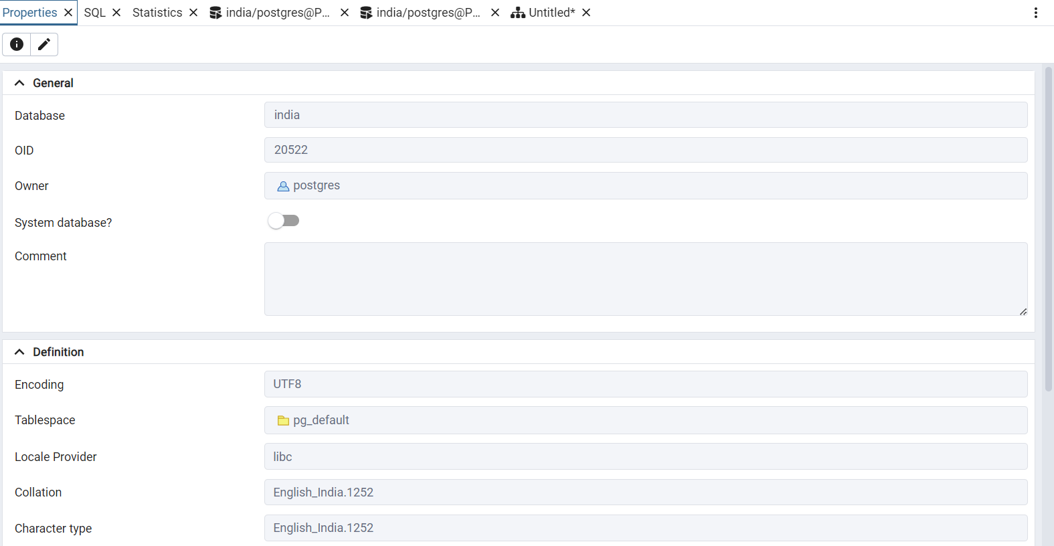

1. *Creating tables*

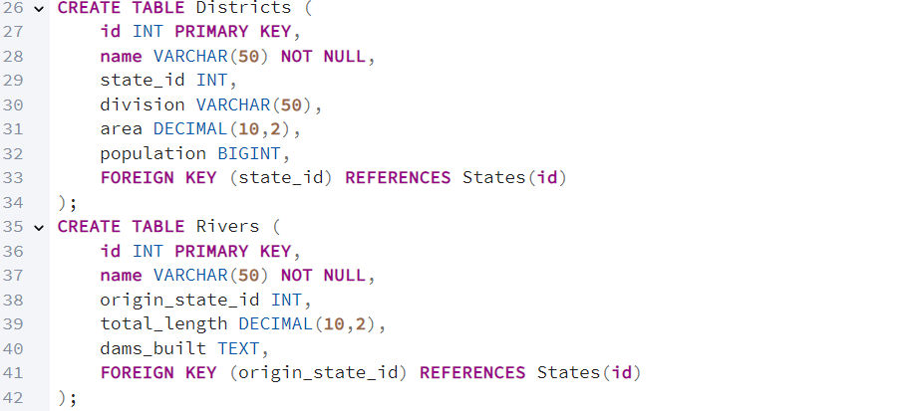 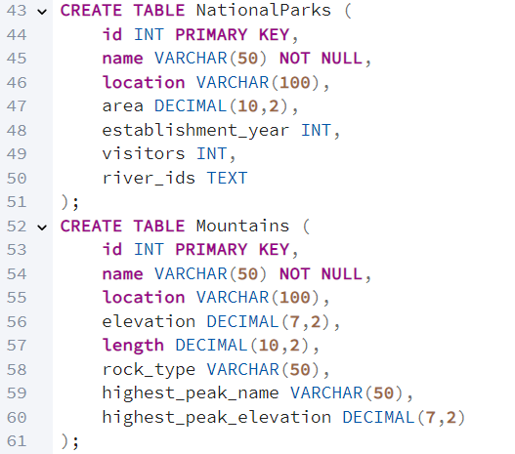

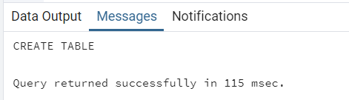

1. *To create Users and assign privileges.*

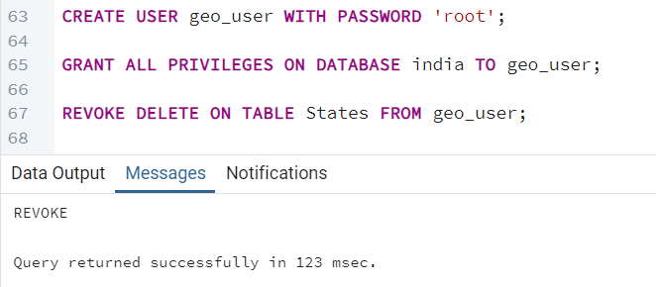

1. *To Generate an ER diagram in postGIS.*

*Expand your database in the Object Browser. Right-click on the* ***database*** *(india) and select* ***ERD Tool*** *from the context menu. This is what we get.*

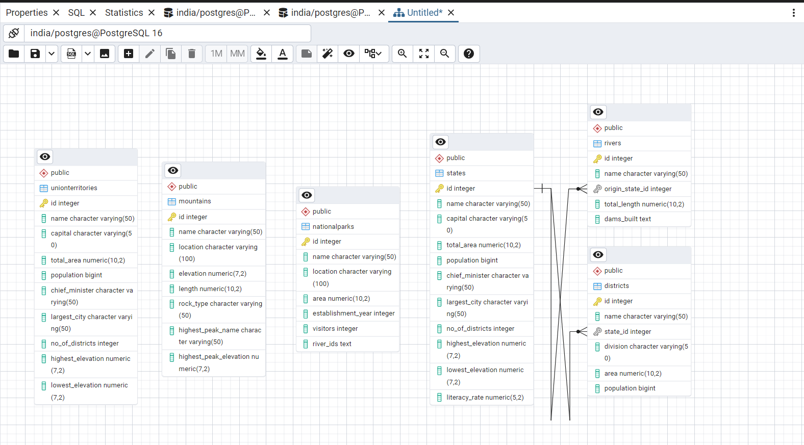

1. *Insert data into the created tables.*

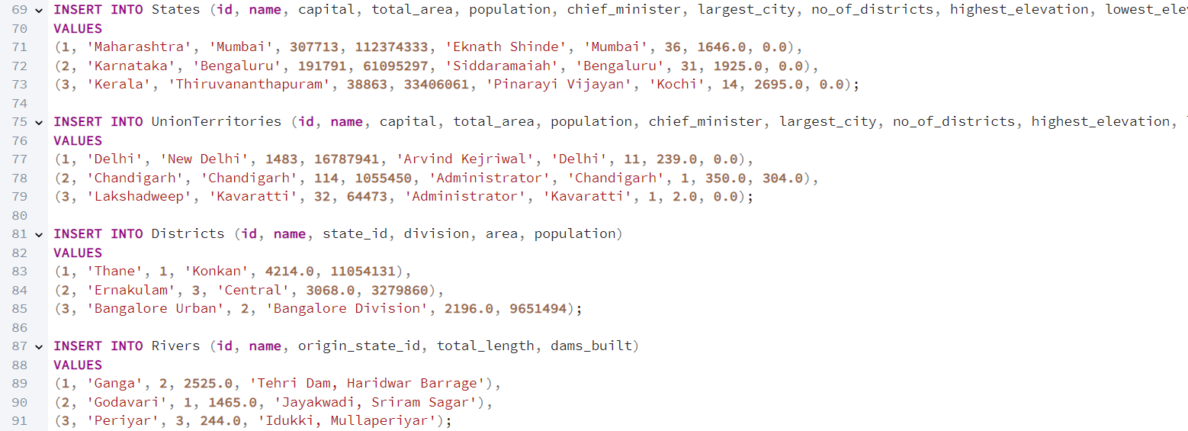 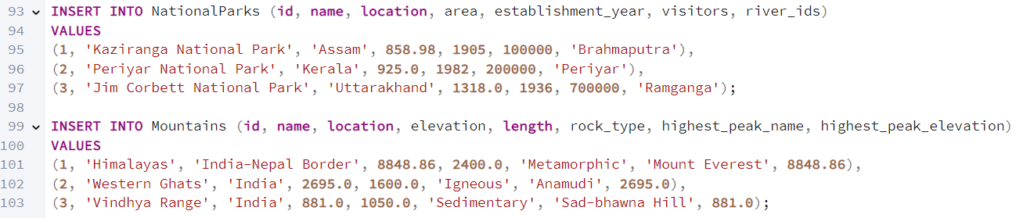

1. *Query the tables*

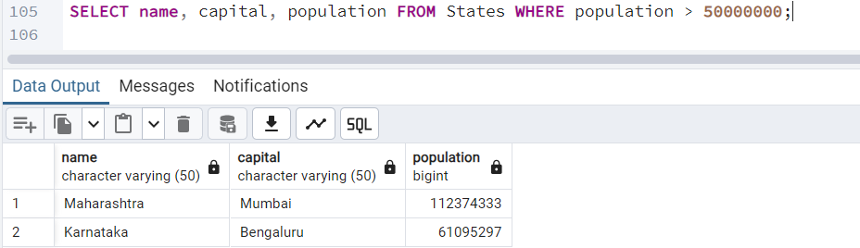

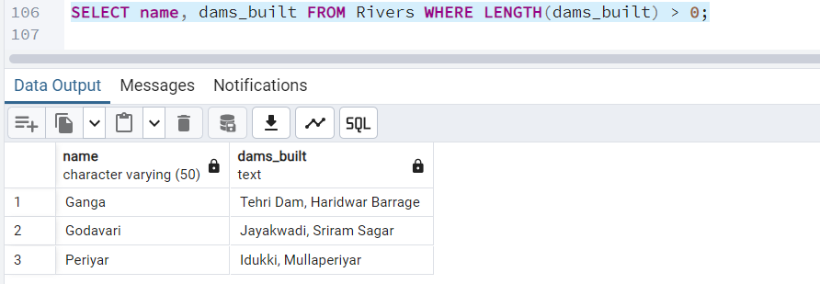

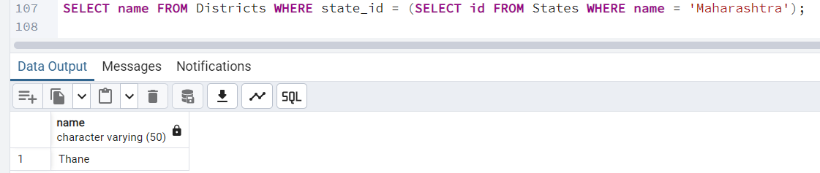

1. *Use other DML, DCL and DDL commands you know to query the tables.*
2. ***Update****.*

**

*Updated table*

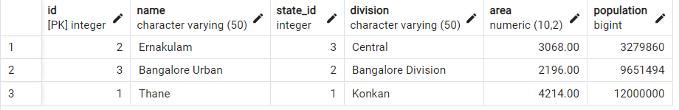

1. ***Delete****.*

**

*Updated table :* 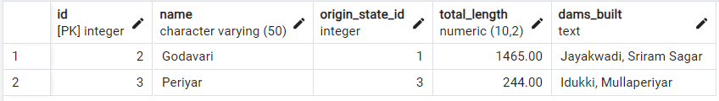

1. ***Alter****.*

**

*Updated table :*

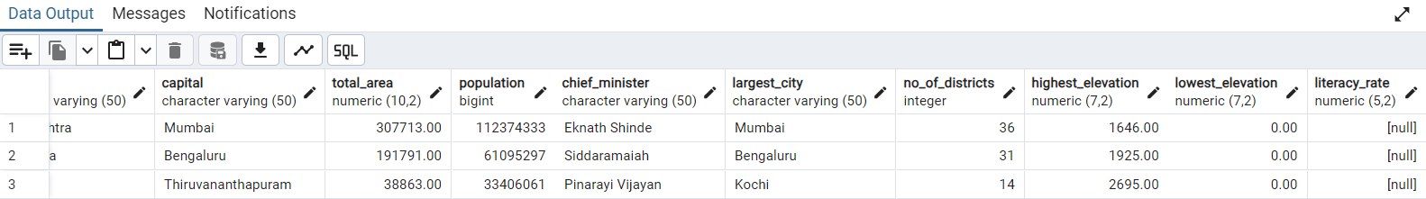

1. ***Drop :***

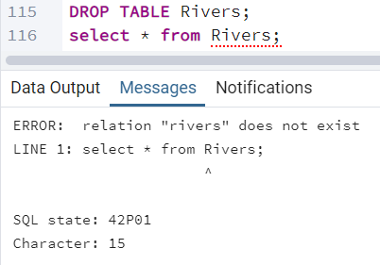

1. ***DCL Queries:***

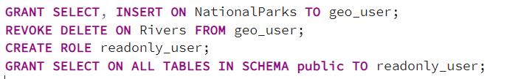

***Conclusion:***

*In this project, we successfully created a relational database named “india” to store geographical and administrative information about states, union territories, districts, rivers, national parks, and mountain ranges. By executing DDL, DML, and DCL queries, we designed and populated the database with structured data.*

*- DDL operations were used to define tables with relevant attributes, primary keys, and foreign key relationships, ensuring proper data integrity.*

*- DCL operations were applied to create users and assign appropriate privileges, enforcing controlled access to the database.*

*- DML queries allowed us to insert, update, and retrieve data from the tables, demonstrating practical applications of the database schema.*

*- We also generated an ER diagram in PostGIS, visualizing the relationships between various tables.*

*Overall, this exercise showed us how relational databases can be used to organize complex, interconnected datasets and how various SQL operations help maintain data consistency, enforce relationships, and manage access control. The result is a robust and scalable model for managing geographical and administrative data for the country.*